From: https://davidstockmanscontracorner.com/bolton-gone-powell-next/

Bolton Gone, Powell Next
By David Stockman. Posted On Wednesday, September 11th, 2019
Folks, when it comes to blithering monetary lunacy it doesn't come any riper than the Donald's latest tweet on the subject.
At 6:42 this morning POTUS should have been getting some extra zzzzs to honor yesterday's sacking of the psychopath who stained America's good name by his very presence in the White House. Instead, he launched what amounts to a Boltonesque, take-no-prisoners regime change war against the Fed:
The Federal Reserve should get our interest rates down to ZERO, or less, and we should then start to refinance our debt. INTEREST COST COULD BE BROUGHT WAY DOWN, while at the same time substantially lengthening the term. We have the great currency, power, and balance sheet.........The USA should always be paying the the lowest rate. No Inflation! It is only the naïveté of Jay Powell and the Federal Reserve that doesn’t allow us to do what other countries are already doing. A once in a lifetime opportunity that we are missing because of “Boneheads.”
This is ignorant bunkum on the substance. And yet, and yet---he's right. Jay & the Fed Heads surely are boneheads.
After all, they have---
- destroyed honest price discovery in the financial markets, which are the heartbeat of capitalism;
- encouraged the C-suites of corporate America to strip-mine balance sheets to fund unproductive financial engineering to the detriment of main street and the benefit of the 1%; and
- off-shored much of the US industrial economy by ballooned domestic costs and wages in pursuit of its idiotic 2.00% inflation target and by subsidizing debt-based consumer binging on imports.
But the very worst of their maleficent doings is the massive monetization of the public debt and drastic suppression of its true cost of carry. That has obviously enabled the entitlement/Welfare State to mushroom without fiscal check or political challenge, but it has also enabled the same bipartisan duopoly to feed Washington's beastly Warfare State without muss or fuss.
So while the Donald has the flow of monetary causation upside down, he's shoved his stubby fingers right into Imperial Washington's open wound. The latter runs rampant around the globe capriciously insinuating its $1 trillion per year war machine into the backyard and front-yard of dozens of nation's who are no threat whatsoever to America's homeland security because it has been essentially exempted from fiscal constraint and therefore democratic control.
That is to say, if president's had to go to Congress for the huge tax increases needed to fund Washington's military/industrial/surveillance/regime change apparatus, the latter would not exist. Nor would there be any policy berth at all for blood-lusting misanthropes like John Bolton-----along with Mike Pompeo, Gina Haspel and the rest of the neocon jackals that the Donald has brought into his government.
Stated differently, at least when America was in harm's way during the Cold War and the Soviet Union had 10,000 nuclear warheads pointed our way there was a palpable threat that might have motivated Congress to fund the national defense with onerous taxes.
Yet since the end of the Cold War in 1990, US defense spending has increased 182 percent in nominal terms, and 44 percent in inflation-adjusted terms. Expressed in constant dollars, Warfare State spending for DOD, foreign operations, veterans and homeland security is now about equal with the all-time peak reached in 2011.
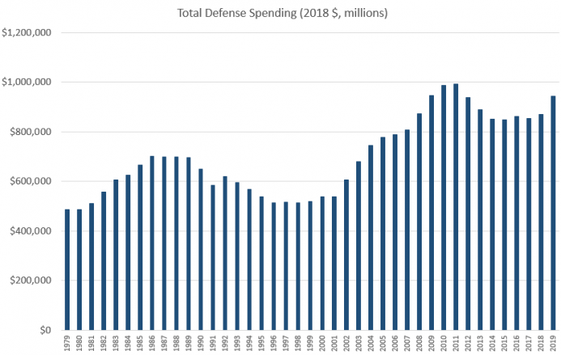
Source: Office of Management and Budget, Historical Tables, Table 3.2.
The fact is, no peace-loving, commerce seeking nation would ever steam its warships into the South China Sea, the Taiwan Straits, the Kerch Straits/Black Sea, the Baltic Sea and most especially not the Persian Gulf.
As we have pointed out many times, and modern history proves beyond a shadow of doubt, every nation which lives in that woebegone neighborhood wants to produce all the oil it can and to keep the gulf open to global commerce because the daily flow of oil tankers is their economic and fiscal lifeblood. And if prices are temporarily boosted to uneconomic heights by the ill-advised political machinations of their despotic rulers---the solution is higher prices, not the Fifth Fleet.
Yet the Persian Gulf has become a Washington-militarized American Lake only because no Congressman had to vote for the $40 billion a pop which is required to build and field an aircraft carrier and its armada of escort ships, war planes, missiles and electronics/surveillance apparatus.
Likewise, a tax-based war machine would never be so easily drafted by rightwing Israeli politicians such as Bolton's equally demented compatriot, Bibi Netanyahu, to conduct what amounts to mercenary dirty work to keep the latter in office.
That's right. Washington's unnecessary and unjustifiable economic wars and military pressure against the likes of Iran, which positively does not pose a threat to America's homeland security, simply would not happen if Congressmen had to vote nay or yea on funding foreign expeditionary forces tasked with furthering the domestic politics of so-called allies.
As it is, however, all of this misbegotten machinery of Empire has been enabled by the mad money printers domiciled in the Eccles Building. They alone keep Uncle Sam's burgeoning debt from crowding out private investment and driving interest rates to what would otherwise by alarming, market-clearing levels.
So the Donald's war on the Fed is one regime change effort that can be heartily applauded. And today's unhinged tweet is all the more evidence that he means business and that as the election nears and the economy stumbles there absolutely will be an all-out attack on the Fed from the Oval Office designed to add Powell to Trump's "you're fired" rooster.
As unseeingly as it sounds, this kind of crude, personalized attack on the Fed chairman is the only thing which will do the job of discrediting the Fed in the eyes of the electorate's unwashed masses. It long ago ceased to provide any benefit to the average voter---if it ever did.
Indeed, new data released by the Census Bureau yesterday confirms that truth in spades. During the last two decades, the median real household income in the US has grown by a tiny 2.6%.
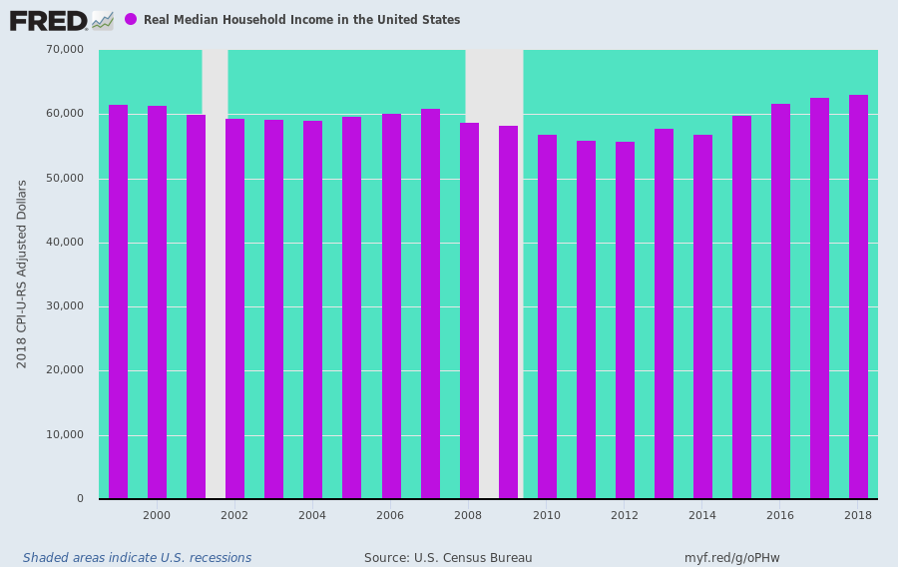
The above chart is just further proof that the Fed's wealth effects policies and stock market propping maneuvers have nothing whatsoever to do with boosting main street growth and prosperity. What they actually do, of course, is shower the top 1% and 10% of households, which own the overwhelming share of financial assets, with the unspeakable windfalls of artificially inflated assets.
Indeed, since the era of Bubble Finance was launched by Greenspan in the late 1980s, virtually the entire increase in real national wealth has accrued to the top 10% of households.
As shown the light green portion of the chart, their wealth in constant dollars has risen from $20 trillion in 1989 to $50 trillion as of 2013, which gain has increased to about $75 trillion since then.
That amounts to a $55 trillion wealth gain over the last four decades for the top 10% of households. By contrast, the bottom 90% has gained less than $10 trillion.
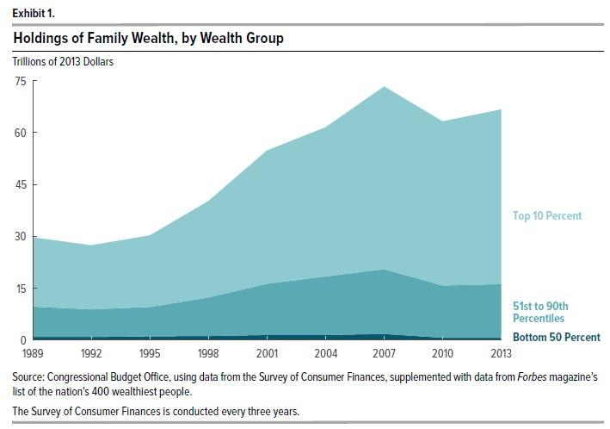
At the end of the day, the economic gods apparently work in mysterious ways. The Donald's call for zero interest rate policy in the US is absurd, and the idea that US interest rates should be the lowest on the planet is straight out of whacko land.
But if he can succeed in administering the Bolton treatment to Powell, there will be some faint hope left for dismantling the current baleful regime of monetary central planning and ending the Fed's perverse monetization of the public debt----the very mechanism that enables the Warfare State and the scourge of Empire Firsters like the now dispatched John Bolton.

